Parkside Medical Practice –Survey Action Plan March 2018
Question | This Survey was discussed with all the Clinical Team and Practice Team at Parkside Medical Practice on 27/03/2018 and discussed with the Practice Patient Participation Group date 28/03/2018 and an action plan has been agreed. | Plan / Date Due
- How good was the GP/HCA/Nurse at putting you at ease?  Very Good 118  Good 12  Satisfactory 16  Poor 4 | Overall all the Staff was happy with the results except for the results received from the 4 patients who gave a rating of poor. Issues were addressed such as where English was not a first language and at times patient demands and expectations are quite high. We all have had training on “Accessibility Guidelines” and Chaperoning and all are aware of showing of compassion, to treat patients with dignity and respect and to try put patients at ease. All Clinicians took this on board however will bear this in mind and try to ensure that all patients are put at ease. | - All Staff to access and review annual training for Accessibility Standards again- within 12 months  - To ensure a Chaperone is offered if there are language difficulties. –ongoing.
2. How good was the GP/HCA/Nurse at listening to you?  Very Good 113  Good 17  Satisfactory 15  Poor 2  Very Poor 3 | All staff was happy with the results except for the result received for 5 patients who gave a rating of poor. Issues were addressed such as where English was not a first language and at times patient demands and expectations are quite high. We all have had training on “Accessibility Guidelines” and Chaperoning and all are aware of showing of compassion, to treat patients with dignity and respect and to try put patients at ease. All Clinicians took this on board however will bear this in mind and try to ensure that all patients are put at ease.  It was discussed at times depending on the problems patients have 10 minutes consultations are simply not long enough and it may seem that the Clinician is not listening however just recently we have discussed this at a Clinical meeting and at a patient engagement meeting and because of this we are asking some patients to come back for a further double appointment if the clinicians deems it to be appropriate. Receptionists are telephoned and it has to be at the clinician’s request and not at the patients. Status markers and reminders have been placed by clinician to those patients whom they think will always need a double consultation due to their health conditions. | - All Staff to access and review annual training for Accessibility Standards again within 12 months  - To ensure a Chaperone is offered if there are language difficulties. –ongoing.  - To continue with double appointments when needed- ongoing.
3. How good was the GP/HCA/Nurse when explaining your treatment and condition?  Very Good 113  Good 16  Satisfactory 16  Poor 3  Very Poor 3  Does Not Apply 0 | Very good results but as a team we discussed that this could be better if more leaflets were also given out explaining the treatment and condition the patient suffers or will suffer from. However yet again there can be a language barrier which could cause a hindrance as they may not speak English or even be able to read English. In instances where printed care plans are provided to patients for example Asthma /COPD reviews management plans are printed off by clinicians from System 1 in English and not in different languages ‘appendix 1’. With the hope that patients could read this at home with family.  In addition to this we have an interpreter service available either for face to face consultations or even over the telephone whichever is seemed to be appropriate at the given time. Staff are aware of the Interpreters Services and book this when requested by the patient or clinicians request or when they are needed however there are times when this does not happen as staff are not aware if the patient requires an interpreter. | - A link is set up in System1 and all non-clinical staff and clinical staff are trained to print leaflets off staff to be trained by office supervisor by the end of April 2018.  - A sign will be placed in the reception advising patients can request leaflets in any language upon request from the clinician/ at the front desk or practice website- 19.04.2018  - To discuss in Patient Engagement meeting to ensure all members are aware so they can inform members of the community- next PPG Meeting April.  - PEL to ensure this link is placed on the practice website for all patients to use IT lead (GT) before 19.04.2018
4. Did you have confidence that the GP/ANP/Nurse will keep your information confidential  Yes, definitely 103  Yes, to some extent 42  No, not at all 3  Don’t Know /can’t say 2 | As a team we discussed these results and despite expecting 100% to result in yes definitely we did receive some results which showed us that 42 patients said yes to some extent and 3 patients said they did not have confidence that we would keep their information confidential. In regards to those patients who felt that they could not have faith in staff we discussed as a team that we needed to work on building their confidence.  The practice has leaflets called ‘how we use your health records’ ‘appendix 2’ and these were placed in front reception for patients to pick up when visiting surgery. | - Place a poster around the practice to inform patients in regards to our confidentiality policy which all staff sign- 15.04.2018  - To discuss in Patient Engagement meeting to ensure all members are aware so they can inform members of the community next ppg meeting 19.04.2018  - These leaflets ‘appendix 2’ will now be physically given to new patients who register with us and will be sent out with appointment letters at random intervals-from April 2018 onwards- Senior Receptionist to implement.
5.Would you be completely happy to see this GP/ANP/Nurse again?  Yes 146  No 4 | From reviewing the results as a team we were happy with these results and feel that as a practice we continuously will strive to provide the best health care we can to patients and ensure they feel like we have taken into consideration all their problems and dealt with them effectively and in the best way possible. | No actions required.
6. Are you aware that you have a choice of where you can be referred to?  Yes 104  No 46 | Despite clinicians and medical secretaries offering patients choice of when/where they would like to be referred to. From this survey we found that 33% of patients are un aware of this choice. We discussed that there may be a chance that some of the patients who answered the survey had not been referred and did not understand what the question entailed. | - Place a poster in front reception- before 19/04/2018  - To text all patients as to inform them of this service. Before 19/04/2018 PEL.  - To add to the practice website. For IT lead (GT) before 19/04/2018  - For Patient engagement Lead to take to the PPG meeting 19/ 04/2018.  - And for all staff to continuously offer and provide patients with a choice in regards to their referral- Secretarial team (office supervisor to implement)
7. How helpful do you find the receptionist at your GP practice?  Very Helpful 135  Fairly Helpful 14  Not very helpful  Not at all helpful  Don’t know 1 | We found the response to this question was overwhelmingly positive and feel our reception staff are continuously improving and learning all the time. If we have a problem we always deal with it in the correct manner and ensure a plan is in place to prevent it from occurring again. | To continue with staff development plans and to continue to work as a team.  Nazmeen Khan (Assistant manager) ongoing.
8. How easy is it to get through to someone at your GP Practice on the phone?  Very Easy Fairly Easy Not very Easy  85 51 14 | Our practice has a new telephone system in place in order to increase efficiency and reduce any problems patients or staff had before. There are a total of four phones lines available on the front desk and back office which reception and admin staff use. The call system is such that is a hunt group meaning that once a person rings if it is not answered at one phone it will continuously be passed from phone to phone until a staff member is available. It will also advise the patient what number they are in the queue. If any calls are missed by staff this is all recorded and at the end of the day the office manager will monitor this number and will try to reduce it by speaking to staff to resolve the issue. | No action required.
9. How easy is it to speak to a GP/ANP/Nurse/HCA on the phone at your GP Practice?  Very Easy Fairly Easy Haven’t tried  49 63 38 | As a team we discussed this result and were happy with the outcome. This is as we continuously are amending and creating new ideas to help patients and deliver the best care we can. All clinicians are provided slots for telephone consultation patients are aware of this and are also provided text messages to remind them of this. | No action required.
10. How quickly do you usually get seen?  Same day or next day 94  2-4 days 39  5 days or more 10  I don’t usually need to be seen quickly 7  11. How do you rate how quickly you were seen  Excellent 112  Very Good 16  Good 9  Very poor 13 | From the results gathered we feel that these were honest answers and provide and positive outlook on our practice as there are same day appointments for patients to book on the day in addition to this there are system online appointments which patients only have access to and can be used for pre bookable appointments for either same day or next available. In addition to this we also offer telephone consultations to those patients who we deem require them. However we observed that 13 patients sated that it was poor which we have taken into consideration and as a team we continuously try our best to provide everyone with the correct health care they need even if it means to advise them to visit the pharmacy who are experts on minor ailments. | - Practice staff to continuously promote the use of online services- Office manager to monitor  - Practice staff to also use signposting to allow patient to see the correct department- ongoing office manager to monitor
12. Did you know that we offer extra appointments at another venue when we are closed?  Yes No  78 72 | As a team we have found that many of our patients did not know that we offered appointments at another venue when we are closed the response for this was nearly 50%. Despite advertising this service within the practice, texting all patients of this service, placing a notice on our practice website and discussing this at our PPG meting we have still found a negative response and feel we should carry out these steps again and continuously implement them daily. | - Update posters in front reception- before 19/04/2018  - To re-text all patients as to inform them of this service- before 19/04/2018  - For Patient engagement Lead to take to the PPG meeting again- 19.04.2018  - To add information to back of every letter that we send out(along with other information). Office supervisor  - For all staff to continuously offer and provide patients with extended access appointments. - ongoing office supervisor to monitor
13. Which of the following additional opening hours would make it easier for you to see or speak to someone  Before 8am 23  After 6:30pm 28  On a Saturday 87  On a Sunday 8  None of these 4 | Form this survey we have understood that patients would like to have a choice of a variety of opening hours however the most popular choice of opening hours was for the service to be opened on Saturdays. For this reason we found majority of these results must be due to patients who work and therefore can only make it for after-hours appointments. With PPG members we discussed that these are available with extended access service such as GP/physio therapy appointments they agreed and said that this service may not be well known to patients., in addition to this we have also been holding late evening GP appointments on Thursday evenings which are available to all patients whether they work, study or need a late appointment. | - Update posters in front reception- Before 19.04.2018  - To re-text all patients as to inform them of this service. Before 19.04.2018- PEL to carry out.  - For Patient engagement Lead to take to the PPG meeting again on 19.04.2018.  - For all staff to continuously offer and provide patients with extended access appointments. - ongoing office supervisor to monitor
14. Are you aware where you can find information about the practice?  Yes No  137 13 | We found that many patients knew where they could find information about our practice and other health information and were pleased with this response including PPG members. This is as the patient engagement leader is constantly providing patients with updates whether it may be due to text or emails whenever they may be a new service or if a update is received. | - PEL to continue to update patients with new information whether it is by text/post- ongoing
15. Are you aware that a GP is made aware and given all telephone calls and messages after his surgery?  Yes No  104 46 | 30% of patients were unaware of this service upon discussion we found that many of the patients may receive appointments and therefore the telephone call/ messaging system does not apply to them. All clinicians are provided slots for telephone consultation patients are aware of this and are also provided text messages to remind them of this. However upon discussion we found that this service must be publicised around the practice as patients may not have used this service before or may not need it. This would be helpful as it may prevent patients from call other out of hours services such as 111/ A&E as there will be a GP available to deal with their queries. | - Place a poster in front reception before 19.04.2018.  - To text all patients as to inform them of this service PEL to carry out before 19.04.2018.  - To add to the practice website For IT lead (GT) before 19.04.2018  - For Patient engagement Lead to take to the PPG meeting on 19.04.2018
16. Do you feel that our reception area is clean and tidy at all times?  Yes No  138 12 | After reviving these results all staff and PPG members were happy with these results as 85% of our patients found that our reception is clean and tidy and we discussed that we must continue to work as a team in order to ensure we continue to provide the best health care we can to all our patients. | Office manager to continue to monitor on a daily basis.
17. Are you aware that we have a private room if you do not wish to discuss anything private at the front reception?  Yes No  139 11 | Majority of our patients were aware that we provide a private room if patients wish to use it for any reason. Only 9% of patients were unaware however we came to the conclusion that maybe these patients have not felt the need to use a private room. However all front line staff always insist that if a patient requires the private room for any reason they always have access to it. | No action required.
18. Are you aware that we have a mobile telephone number to enable you to text us to cancel an appointment?  Yes No  66 84 | From discussion we found that this was a point which seemed majority of our patients did not seem to think was available to them we decided this needed to be publicised more often around the practice as we believe that this method would help increase efficiency and create more availability for other patients instead of patients ringing and cancelling last minute reducing another patients chance of being seen by the clinicians they require as once we receive a text we can cancel a patients appointment | - Place a poster in front reception before 19.04.2018.  - To text all patients as to inform them of this service before 19.04.2018  - To add to the practice website For IT lead (GT) before 19.04.2018.
19. After seeing your GP do you understand your health problems?  Very well Unsure Not very well  134 12 4 | As a team we discussed the following results and found that majority of patients felt that the clinician involves them in their care did try his/her best in explaining and helping the patient understand their health problem. For those patients who were unsure and were not so happy with this we found that many of them may have had difficulties such as language barriers in which the clinician was explaining something in a language that was foreign to them, this is why we always stress that patients must contact the surgery if they would like someone to interpret for them so we can arrange an interpreter to attend with them for a face to face or even a telephone consultation. All staff and PPG members agreed that this would help the patient and clinician to explain the patients’ health problems in a way he is able to understand we also mentioned that this is always included in all letters we send out to patients. | - Place a poster in front reception to remind patients of this service before 19.04.2018..  - To text all patients as to inform them of this service for PEL before 19.04.2018.  - To add to the practice website. For IT lead (GT) before 19.04.2018.
20. After seeing your GP how do you cope with your health problems?  Very well Unsure Not very well  137 9 4 | We found that many patients were able to cope with their health problems very well which all staff were happy with and were advised to continue to continue with this quality of care. Clinicians also continue to stress the importance of self-care to patients in addition to front line staff rather than GP appointments there are other services available which may suit them better this is done through sign posting for e.g. instead of a patient going to the GP for ongoing physio advice we can book them an appointment with physiotherapist via extended access appointments. | - Practice staff to also use sign posting to allow patients to see the correct department- Office supervisor to monitor.  - Ensure practice leaflets are readily available Reception supervisor to manage.
21. Overall, how would you describe your experience at your surgery?  Excellent Very Good Good  83 39 28 | All of the patients had an extremely positive answer to the following question which all staff were extremely happy with as were the PPG members. All staff were advised to continue with the hard work to provide all patients with the best quality of care. We continuously strive to provide the best health care we can to our patients and ensure they feel like we have taken into consideration all their problems and dealt with them effectively and in the best way possible.  Please see ‘appendix 3’ | All staff to continue with staff development plans and to continue to work as a team.
Are you: | Male Female  69 81
22. How old are you? | Under 16 16-29 30-44 45-64 65-74 75 or over  1 36 50 23 12 28
24. What is your ethnic Group? | White Black or Black British Asian or Asian British Mixed Chinese Other ethnic Group  9 4 126 3 2 6

Appendix 1

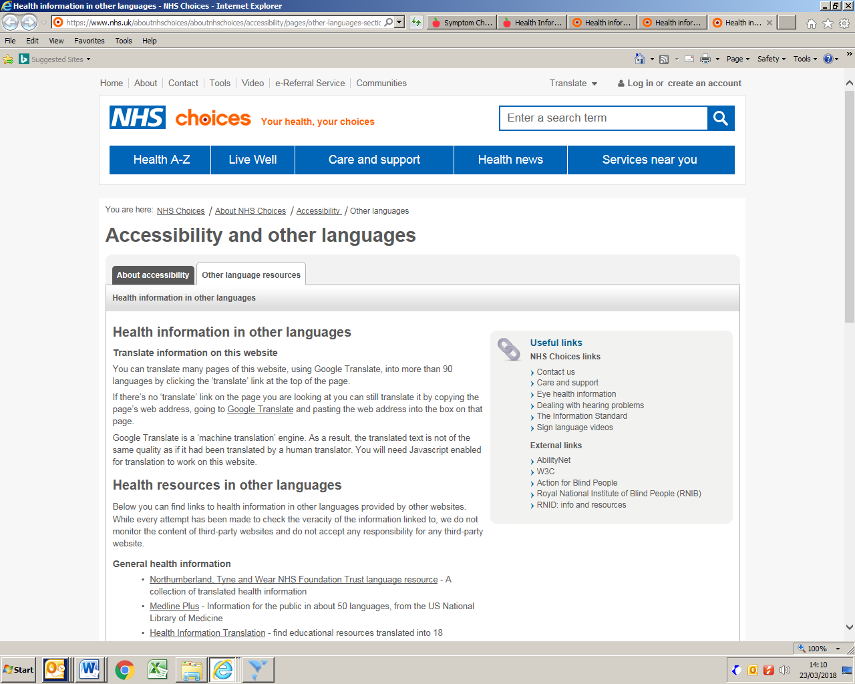

Appendix 2
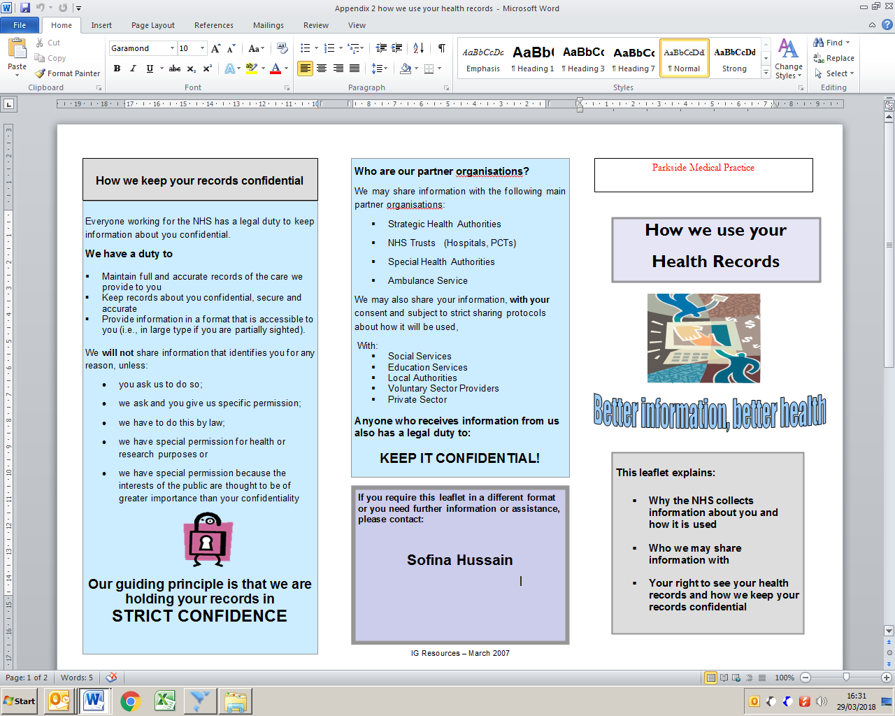
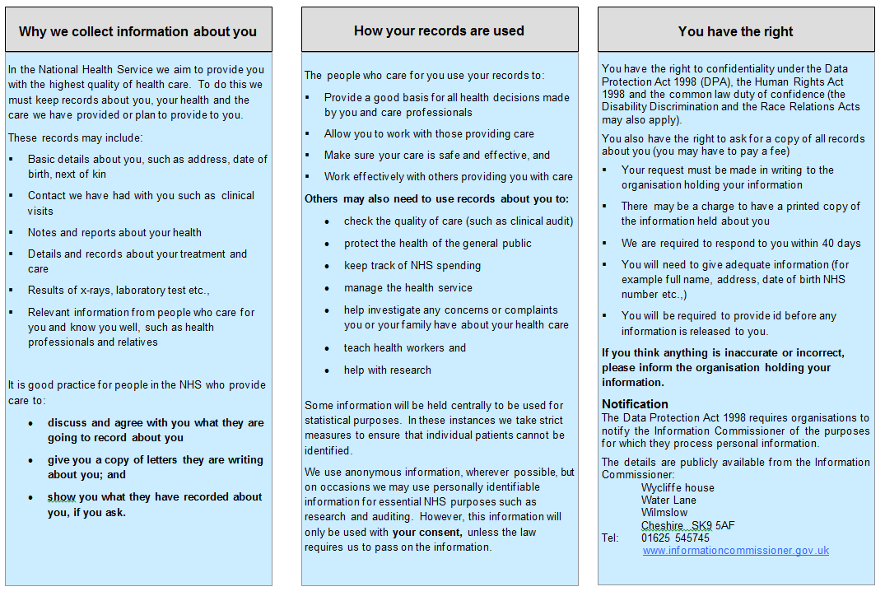
Appendix 3
Comments received from Patients from 2017- 2018 Practice Survey
Dr Jahan, very reassuring, polite respectful. An amazing doctor and amazing staff.
Nurse Barbarah is so nice.
Sue- amazing can always trust 100%.
Nurse Sue very amazing.
Nurse Barbarah is excellent
Sue always a pleasure, kids love her.
Dr Javid, the best GP who takes time to listen and give you the best medication. He is an excellent GP with exceptional qualities of listening and giving advice
Dr Khan Very good and Understanding doctor.
Nurse Sue good and Helpful.
Susan Gavin and Dr Javid could not have received better care.
Well I almost know the whole team, everyone is great.
Sue is always thorough and is never judgmental. Explains things patiently and has always shown respect and compassion to me and my family.
I saw sister Gavin she is the best I think she should get a pay rise.
All members of staff are brilliant
Susan Gavin is very helpful, great and the staff are the best
Very happy with Dr Azam
Midwife and Susan Gavin were very good
Dr Roohi was very helpful
Susan Gavin was extremely professional excellent treatment and very very good communicator one of the best in the surgery.
Dr Roohi as she is a female Doctor and she listens to my problems very carefully every time and she diagnoses my problems very sincerely. As a patient I’m satisfied with her and want to see her for my health issues.
Susan She has been very helpful I can feel comfortable talking to her.
Susan Gavin is the best.
Dr Azam a great doctor who always listens and explains my problems.
Susan Gavin is great.
Susan Gavin was very helpful in terms of information.
Dr Roohi Azam was very helpful.
I like the way Sue treats her patients.

